**Agent-Based Simulation for Human Mobility Process of Infectious Diseases**

Ze-Dong CHEN

**Keywords:** Agent-based Model, Human Mobility, Epidemic Transmission.

**Abstract:** Infectious diseases were viewed as a serious threat to human society since ancient times. In the last several decades, a series of approaches has been devised to model epidemiological processes. Human mobility expanding the scope of the distribution of pathogens is a pivotal component of large-scale transmission models of infectious diseases. Correctly, modeling and qualifying human mobility is critical for improving epidemic prevention and control. This article proposes an agent-based epidemic model to simulate human mobility process of infectious diseases. Agent-based model simulate epidemiological processes by angle of micro is more significant than traditional mathematic method. The research findings will provide a more rational basis for epidemic prevention and control.

**Introduction**

Infectious diseases are caused by pathogenic microorganisms, such as bacteria, viruses, parasites or fungi. The diseases are be spread, directly or indirectly, from one person to another. Zoonotic are infectious diseases of animals that can cause disease when transmitted to humans [1].Human society is facing a huge threat of infectious diseases. Some infectious diseases such as SARS, highly pathogenic avian influenza and Ebola virus had a significant impact on public health and social life occurred in recent years. How to contain infectious diseases outbreak and mitigate epidemic spread has been a pressing issue of society.

Exploring the potential law and simulating outbreak process of infectious diseases, a range of approaches had been proposed by scientists. These include: mathematical epidemiological models , complex network models and microscopic models. These models had been widely used in different types of infectious diseases research recently.

Mathematical epidemiological models are commonly known as SIR models [2].These models divided population into three mutually exclusive segments. One segment includes those individuals who are susceptible to the disease (S). A second segment is composed of those that are infectious and can spread the disease to the susceptible individuals (I).The last segment refers to those who are recovered from diseases (R) [3].Furthermore, the infectious segment has been further divided into two segments, those who are exposed to an infection and those who are infected constructing a SEIR model [4]. Differential equation set were used to express these models [5].

Complex network models can render contact relationship between individuals. Individuals of population are treated as nodes in the network and the contact relationship between individuals are represented by edges. A metapopulation network model has been proposed to simulate epidemics in large-scale spatial transmission [6]. Constructing two-scale (local and societal) social network to model communicable diseases spread in individuals is authentic [7].

The spread of infectious diseases is a complex diffusion process from the perspective of system science. Microscopic models are helpful for understanding the mechanism of infectious diseases and recognizing the inherent laws. Individual-based models as significant microscopic models include cellular automata models and agent -based models [8].

Human mobility as a key component of epidemic models was ignored in past research owing to the shortage of actual data or suitable models. In this paper, an agent-based epidemic model including the process of human mobility is constructed. Simulating a certain number of individuals moving between regions shows the transmission of epidemic. Lacking the actual data lead to the fact that all parameters was assumed in the model. Actually, all of these parameters can be obtained from the actual data in future research.

**Conceptual Model**

An agent-based model was developed to interpret the transmission of infectious diseases. Each individual in the model is implemented as an agent. Each agent has its own attribute and behavior in the model. A complete list of their attributes are shown in Fig.1. Multi-Agent can effectively simulate the whole process of epidemic in the crowd. A SEIR (Susceptible, Exposed, Infected and Recovered) model was used for the human submodel. The infection status of agent changed with the pathological process.

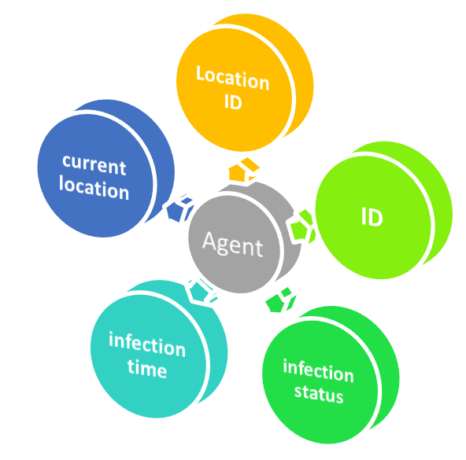

Fig.1 Attributes of an individual as an agent

ID indicates personal identification. Location ID indicates individual original location and current location refers to individual location after movement. Infection status contain four stages: susceptible, latent, infectious, recovered. Infection time denote day of receiving infection controlling the cycle of diseases.

The transmission of infectious diseases is not just a status change in population but also a propagation in space driven by human mobility from one region to another allowing mixing and importation [9]. To simulate the process of agent mobility in space, ten regions (From 1 to 10) were created. A matrix represents the flow of human mobility between regions.

$Flow=\sum_{\begin{aligned}i(1, 10) \\ j(1,10)\end{aligned}}{P\left(i,j\right)}$. (1)

The formula (Eq.1) represents the flow between ten regions and $P\left(i,j\right)$ indicates the number of individuals from one region to another. The flow of mobility is shown in Fig.2.

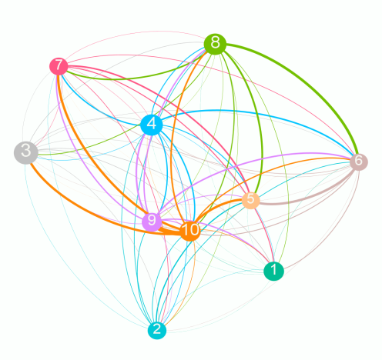

Fig.2The flow of human mobility between 10 regions

Heterogeneity of epidemic transmission rates should be considered .Demographic, natural and socio-economic factors play significant roles in transmission rates in reality. Interventions of local region should also be considered in the programs of prevention and control.

**Model Implementation**

The proposed agent-based epidemic model is implemented with some parameters (Table1). The validity of these parameters determine the fitness of the model. Parameters should be obtained by statistical and investigatory data. The agent-based model had been implemented by computer program. We created 150000 agent distributing in 10 regions in the model randomly. All parameters in the model were assumed. The number of daily patients in regions had been counted as an outcome of model running (Fig.3(a)). Taking local intervention for some regions with larger immigration was efficient to reduce the number of patients (Fig.3(b)).

Tab.1 Description of parameters in the model

|  |  |
| --- | --- |
| **Parameter** | **Description** |
| NRegion | The number of regions |
| LocalPop | The total population of each region |
| Scase | The number of patients started |
| PopFlow | The flow of human mobility between regions |
| NewCase | Number of new cases per day of each region |
| InfectionCycle | The duration of various stage of epidemics |
| Environment | Temperature, rainfall and evaporation |

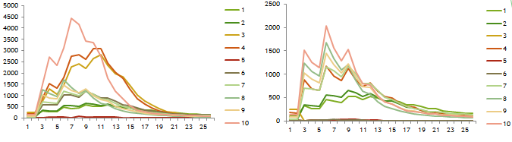

Fig.3 (a) number of patients in regions (b) number of patients in intervention

The dispersion of infectious diseases in a population is intrinsically spatial and temporal [5]. Infectious diseases, combined with geospatial information have a great significance for epidemic prevention and control. The evolution of infectious diseases could display in the geographical space intuitively (Fig.4).

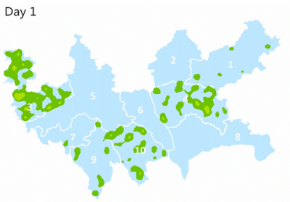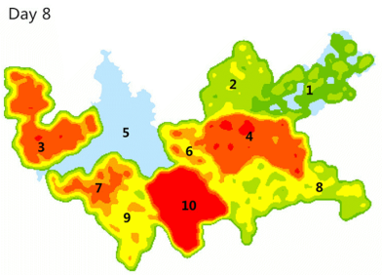

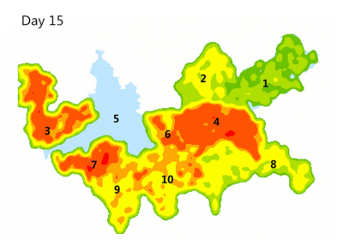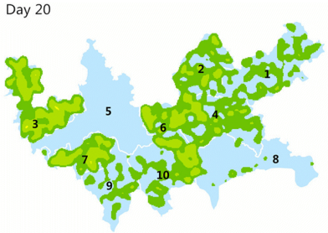

Fig.4volution of infectious diseases in the geographical space

**Summary**

The agent-based epidemic model stimulates the human mobility process of infectious diseases and the disease severity could be controlled by taking some interventions in regions with larger immigration. The evolution of infectious diseases containing geospatial information is valuable. Its pity that parameters in the model are assumed for lacking actual data but the proposed model is valuable for future research.

**References**

[1] Information on http://www.who.int/topics/infectious_diseases/en/.

[2] kermack WO and Mckendrick AG.A contribution to the mathematical theory of epidemics. 0roceedings of the Royal Society of London ,1927,A 115:700-21.

[3] Anderson R M and May R M. Infectious Diseases of Humans: Dynamics and Control. New York, Oxford University Press,(1991).

[4] Hethcote HW. The mathematics of infectious diseases. Siam Review,(2000).

[5] Ling Bian. Spatial Approaches to Modeling Dispersion of Communicable Diseases-A Review. Transactions in GIS,2013,17(1):1-17.

[6] Colizza V and Vespignani A. Invasion threshold in heterogeneous metapopulation networks. Physical Review Letters,2007,99(14):148701.

[7] Ling Bian and Yuxia Huang. Modeling Individual Vulnerability to Communicable Diseases: A Framework and Design. Annals of the Association of American Geographers,2012,102(5).

[8] Simoes JM A. An Agent-Based Approach to Spatial Epidemics through GIS, Center for Advanced Spatial Analysis & Department of Geography, University of London, (2006).

[9] Tizzoni M, Bajardi P, Decuyper A, Kon Kam King G, Schneider CM, et al. On the Use of Human Mobility Proxies for Modeling Epidemics. PLoS Comput Biol,2014 10(7): e1003716.